Leave empty 30 mm from top margin only on first page

PAPER TITLE
(14 pt Times New Roman Bold, 6 pt before, 12 pt after, centered))
J.R. ANDERSZ, J.K. LINES
University of California
Department of Mechanical Engineering
e-mail:
(authors, 12 pt, Times New Roman, 6 before, 12 pt after, centered)
Keywords: CAD, geometry, manufacturability (11 pt, Times New Roman, 12 pt before, 12 pt after, centered)
Abstract: The abstract should be written by 10 pt Times New Roman, Italic, 6 pt before, 24 pt after, 1 mm from left and right margin. Please do not exceed 10 lines.

GENERAL INFORMATION

This page is formatted according to the instruction. You can use it as example how the finished paper should look.

The paper will be printed in 2-columns, format A4 size. Each column is 75 mm wide with a gap of 10 mm between them.

Please use even number of page (not more then 8-10 pages).
Page layout: format A4, margins: top 20 mm, bottom 20 mm, left 30 mm, right 20 mm.
Typeface for all text: Times New Roman, 10 pt, single spacing.
On first page leave 30 mm for Seminar logo.

1. FIRST ORDER HEADINGS
First order headings should be in bold 12 pt Times New Roman with 12 pt before and after, left hand margin.
1.2. Second headings
Second order headings should be in bold 12 pt Times New Roman with 6 pt before and after, left hand margin.
1.2.3. Third and other headings
Third and other headings: bold 10 pt Times New Roman with 6 pt before and after, left hand margin.
Equation: should be centered in each column, number of equations in parentheses placed at right-hand margins of each column. Long equations can be typed across both columns.
$f(x,y)=\sum{\frac{a}{b}}ϕ(x)⋅ψ(y)$ (1)
References: should be given in square parentheses [1]. A numerical list of references should be given at the end of the paper. The format is: name, the title (by italic), the abbreviated name of the journal, volume number, the year, page numbers.
Figures, graphs and photos: should be embedded as one of the standard Microsoft objects. To avoid any problems, please attach them in separated files e.g. in .pcx, .tif, .gif format. Please do not use Microsoft Drawing tools directly on the page (use embedded object) and avoid Float over text option. Each figure should be accompanied by a legend in italic (6 pt before and after figure and legend). Biggest figures can be embedded across two columns. Only black and white photographs will be acceptable in high contrast quality.
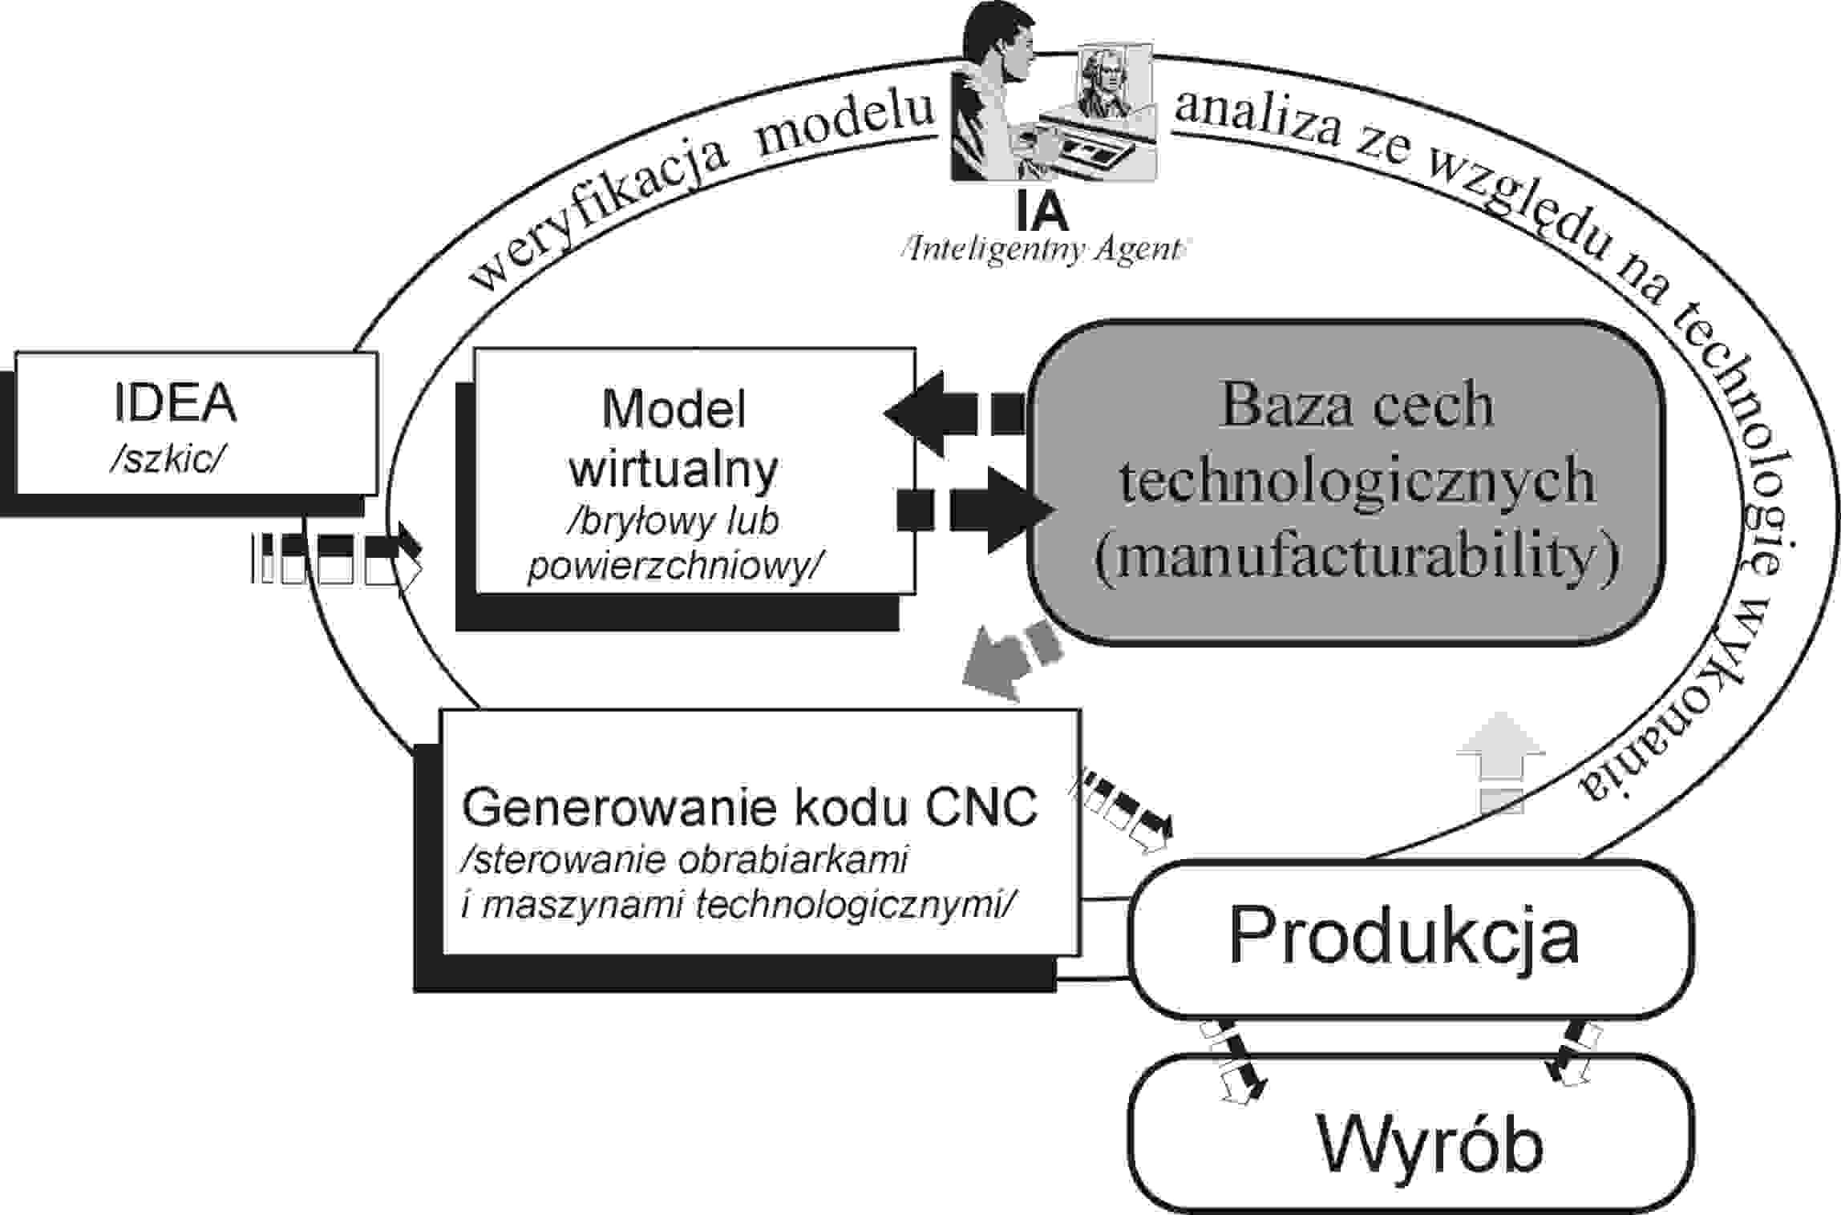
Fig.1. Schematic representation of …
Tables: should be numbered following the word Table. Each columns should be clearly headed and incorporates the appreciate symbols and units.
Table 1. Influence of …
Acknowledgements: should be included before the list of references.

References
- Lee, B.Gee, Virtual Reality in Engineering, ISE Trans. on Engineering, Vol.22, 2001, pp.10-20

If there is any problems with electronic e-mail, please submit two copies of the manuscript accompanying to WinWord format.
Do not number the pages (only on the back with a soft pencil).

